**THE TABLEAU HR SCORECARD: MEASURING SUCCESS IN TALENT MANAGEMENT**

INTRODUCTION 1.1 overview

Talent management strategy requires a multi-faceted approach that addresses various stages of the employee lifecycle. This header explores the core components that collectively contribute to a thriving talent management strategy.

The first step in building a talented workforce is attracting the right individuals. Efficient recruitment processes focus not only on filling positions promptly but also on finding candidates who align with the company’s culture and values.

Investing in employee growth is an investment in the organization’s future. Offering continuous learning opportunities, skills enhancement, and career advancement paths not only cultivates a skilled workforce but also nurtures a culture of innovation and adaptability.

1.2 Purpose

Lapses in communication with qualified candidates—and a lack of tools to push the top applicants through the process—impact your ability to hire the best people. Processes and technology that help with workforce planning, sourcing, applicant tracking and analytics are important to an agile recruiting process.

When companies tie training and development opportunities to performance goals, employees are more engaged in their work and stay with the company longer. Talent management systems make it easy to track goals and match employees with the right opportunities to help them progress in their careers.

**PROBLEM DEFINITION AND DESIGN**

**THINKING**

Designthinking

Empathy Map is a tool that helps designers empathize with the people for which they are designing a solution. With empathetic mapping the designer/developer put themselves in the position of the user. Empathy Maps can also be used to test a prototype design or in activities such as role playing to help better understand the needs of the user.

problem definition

An HR scorecard identifies department areas that have an impact on the organization’s goals. Productivity, turnover, promotion and employee satisfaction are common categories for an HR scorecard. HR scorecard categories aren’t static. They change according to the organization's needs, previous scorecard measurements and the effectiveness of HR functions and outcomes

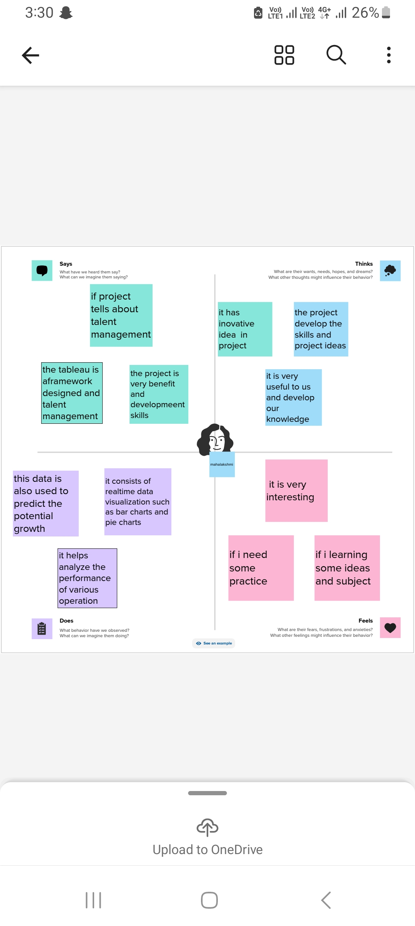

2.2 IDEATION & BRAINSTORMING

Ideation

Ideation is often closely related to the practice of brainstorming, a specific technique that is utilized to generate new ideas. A principal difference between ideation and brainstorming is that ideation is commonly more thought of as being an individual pursuit, while brainstorming is almost always a group activity. Brainstorming is usually conducted by getting a group of people together to come up with either general new ideas or ideas for solving a specific problem or dealing with a specific situation.

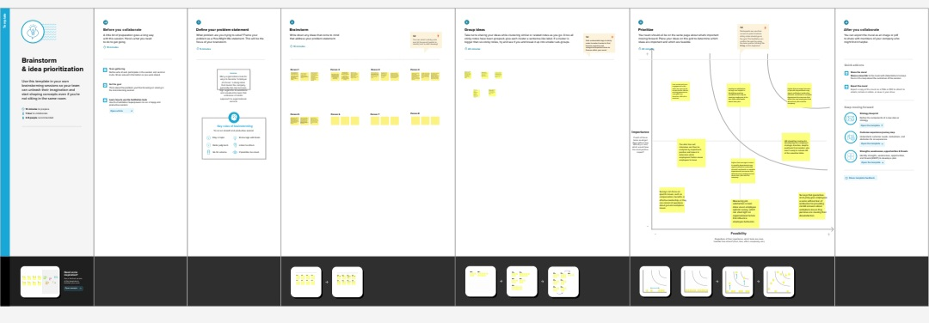

**RESULT**

An employee scorecard is a supervising method management professionals use to review an employee's performance. Usually consisting of a list of important qualities, skills and daily tasks, employee scorecards can help motivate employees to improve their production.

An employee scorecard is a tool managers use to rate and monitor the quality of an employee's performance. These scorecards often vary by company and specify different aspects of an employee's work expectations.

Expected quota and results

Key responsibility

Skills

Core values

Specific duties

**ADVANTAGES AND DISADVANTAGES**

**Advantages:**

**1. Brings structure to business strategy**

Different departments within an organization may have their own way of measuring performance and what they consider to be important in terms of metrics. With a balanced scorecard, different leaders and departments can still individualize their performance measurement, but it all falls within a set structure that can be understood across the organization. It gives a common place to everyone in the company to measure success.

#### **2. Makes communication easier**

Communication across team members and departments becomes easier when everyone is speaking the same language. In other words, having a streamlined performance measurement system means that it’s easier to talk about strategy and progress within the organization.

#### **3. Facilitates better alignment**

With a balanced scorecard, members of the organization can easily link their objectives and goals at different levels of the company. It takes the guesswork out of trying to understand everyone’s responsibilities and it gets teams and departments synced up under one structure. This also leads to having a much clearer picture over projects and initiatives, which hopefully turns into a shorter turnaround time with more optimal results.

**Disadvantages**

**1. It must be tailored to the organization**

A balanced scorecard is supposed to provide a framework from which to work from, however, it will still need to be customized to every organization using this system. This can take up a lot of time, and while examples are helpful, they can’t be copied exactly due to the unique needs of every business.

#### **2. It needs buy-in from leadership to be successful**

For the balanced scorecard system to be fully effective, it must be implemented from the bottom all the way to the top of the organization. This means getting buy-in from leaders, which can sometimes take some convincing, not to mention the learning curve involved with getting the whole organization to use the new system.

#### **3. It can get complicated**

The framework itself of balanced scorecards takes some time and dedication to understand. There are countless resources and case studies to read from and it’s easy to get bogged down with the many different ways of using this method.

**APPLICATONS**

The HR scorecard is a tool that helps measure, manage and improve the role of the HR function within an organization. HR metrics and KPIs or HR deliverables are measured using the HR scorecard. This data is also used to predict the potential growth of the organization.

It helps the managers monitor several operations in a company at the same time. And for each of them, develop specific goals and measures to achieve the goals. Company officials can concentrate on four perspectives through this document, which are “Financial, Internal Business, Customer and Innovation- Learning”.

**CONCLUSION**

At the end can say that talent management process has provide new ways to Human Resource department to handle problems faced in hiring talent. By the help of talent management process companies are hiring right person for the right job as per their job requirement and description.

Talent management in an organization aims at ensuring employee recruitment, training and development, performance reviews and their compensation. Working towards enhancing a good talent management system in the organization ensures these components of human resource contribute to the success of the organization.

**FUTURE SCOPE**

The future of HR Analytics is all about leveraging data to make informed decisions related to the workforce. By measuring, analyzing, and interpreting HR metrics and data, organizations can gain valuable insights into employee performance, engagement, turnover, and more.

The recruiting and selection process may be

enhanced with the use of HR analytics.

Organizations may find the greatest talent sources, improve their job advertising, and pinpoint the traits of successful recruits by studying candidate data and previous hiring choices.

**APPENDIX**

